**Screen capture of unit testing**

**DataAccessLayerTest:**

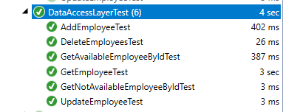

**BusinessLayerTest:**

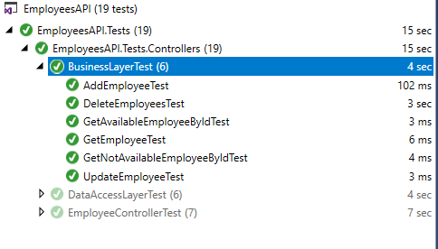

**EmployeeControllerTest:**

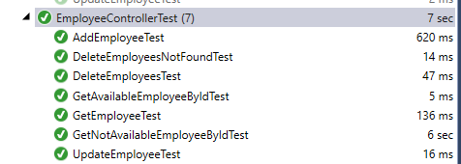

**Screen capture of Code Coverage:**

**Business Layer:**



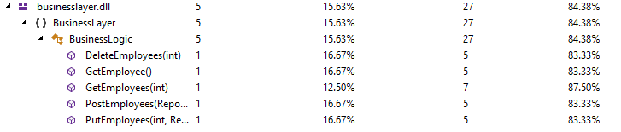

**DataAccessLayer:**



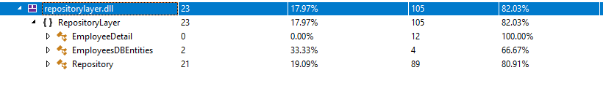

**EmployeeController:**

